**PROPOSED METHODOLOGY**

RFID tagging is an ID system that uses small radio frequency identification devices for identification and tracking purposes. An RFID tagging system includes the tag itself, a read/write device, and a host system application for data collection, processing, and transmission.

In simple words an RFID uses electromagnetic fields to transfer data over short distances. RFID is useful to identify people, to make transactions, etc.

You can use an RFID system to open a door. For example, only the person with the right information on his card is allowed to enter. An RFID system uses:

>> tags attached to the object to be identified, in this example we have a keychain and an electromagnetic card. Each tag has his own identification (UID).

[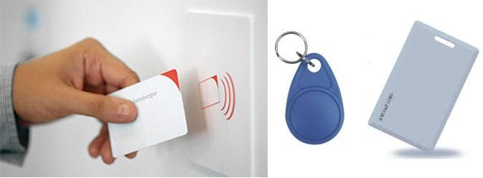](javascript:openLightBox('4fbab1e809',%200);)**Fig No. 3 -Keychain and Electromagnetic card are commonly used tags**

>> two-way radio transmitter-receiver, the reader, that sends a signal to the tag and read its response

[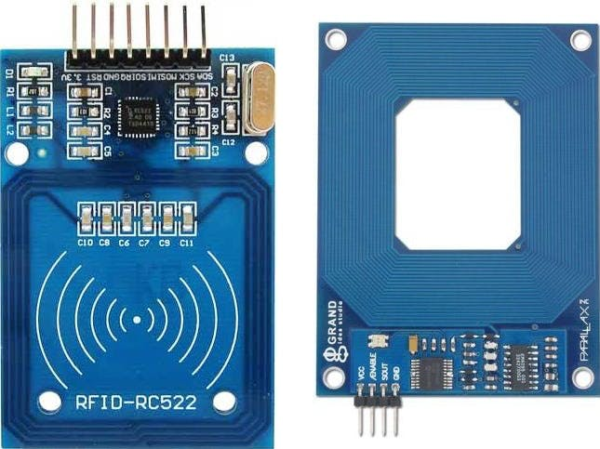](javascript:openLightBox('0ea6f34a3d',%200);)**Fig No. 4 -Radio transmitter receiver**

Basic Specifications:

* Input voltage: 3.3V
* Frequency: 13.56MHz

Now, before typing out the necessary code, you need to download the necessary library for this sensor from this [repository](https://github.com/AritroMukherjee/RFID).

Method of automatic identification through radio signals that can bring you security and control the access of people to a certain location.

This is possible through radio frequency identification or RFID from the English Radio Frequency Identification. And it is the assembly of this system that I am going to teach you today.

This system works with a card or it can also be a key chain that has a chip inside it. Through the identification of the data of this card or chip is that it is possible to do access control, a method widely used in records of employee points, public transportation, libraries, among others.

Our goal, therefore, is to create a program in which we can either read an RFID card (or tag) or write the data to it. We use a WiFi NodeMCU-32S and an RFID-RC522 module.

It is important to note that we can store and retrieve data on these chips or cards remotely through devices, as these have up to 1k of memory.

**Operation**

An RFID system basically consists of a transceiver with a decoder and an antenna and a transponder. And how it works? These cards have a reel inside them. When you approach them from the reader, they emit a radio signal through the antennas connected to the reader. The energized tag, which is the card, modulates the information stored in its memory and sends that data to the reader. This card then enters the reading field and receives power from the reader to perform the operations. The RFID reader receives the information sent by the tag, decodes and sends the data to the server application.

**Fig No.5: Memory**

As mentioned, we have 1k of memory inside this type of chip. And, the EEPROM memory is organized as follows: there are 16 sectors of 4 blocks. Each block contains 16 bytes. Remember that within the source code, you only reference the block number

[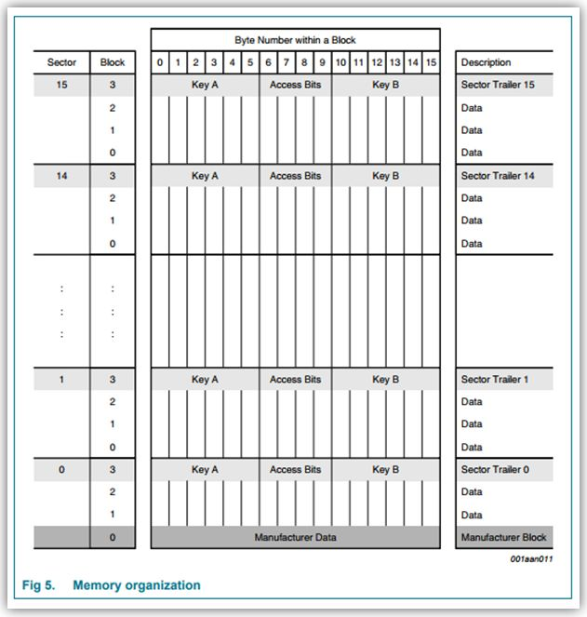](https://cdn.instructables.com/FEY/Y6QL/JF2SVQLW/FEYY6QLJF2SVQLW.LARGE.jpg)

.

**Fig No.6 :WiFi NodeMCU-32S ESP-WROOM-32**

[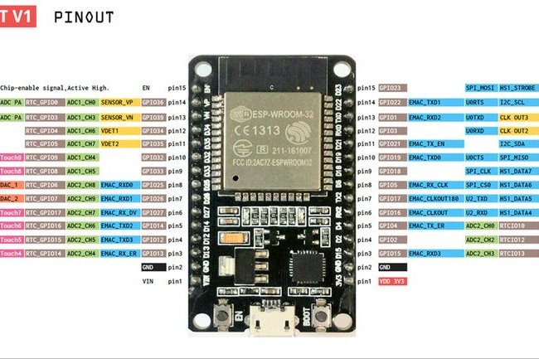](https://cdn.instructables.com/F1F/OE4A/JF2SVQRY/F1FOE4AJF2SVQRY.LARGE.jpg)

[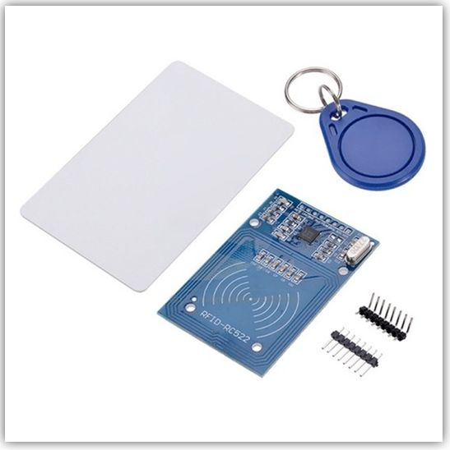](https://cdn.instructables.com/FXJ/MV4I/JF2SVSY4/FXJMV4IJF2SVSY4.LARGE.jpg)

**Fig No. 7 -RFID Tags**

[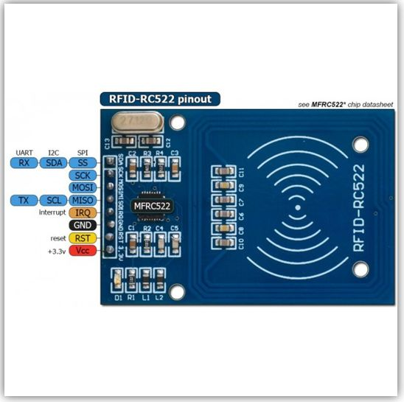](https://cdn.instructables.com/FBJ/E13M/JF2SVSY8/FBJE13MJF2SVSY8.LARGE.jpg)

**Fig No.8-RFID Antenna**

Here we have images of the card and the key ring, as well as the RFID antenna. An important detail is that its Interface is SPI.

**Assembly**

[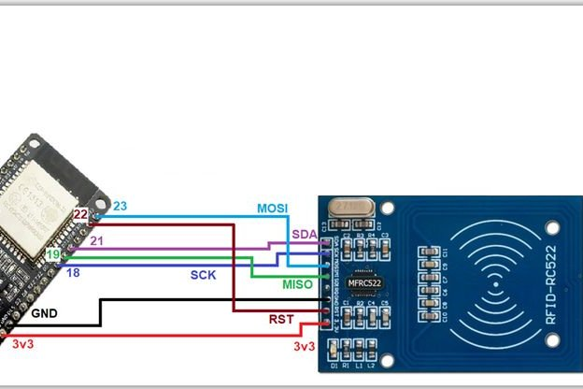](https://cdn.instructables.com/FVT/7HYT/JF2SVT0C/FVT7HYTJF2SVT0C.LARGE.jpg)

**Fig No.9-Assembly**

In our assembly we have the ESP32 powered by USB and also connected in the serial of the Arduino IDE, two leds to indicate whether the reading was successful or not, and the RFID reader, the RC522. We have the keyring with chip and the card.

Placing the key ring over the player shows the option of 0 for reading data and 1 for recording this data. We do an example that shows that after reading the chip or card, if the green led is lit the reader recognized the number. In case of the red led, it means that some type of error occurred and the authentication was not performed.

**SOURCE CODE**

Here is the code made in python for the functioning of the RFID system along with the buzzer.

#include "FirebaseESP8266.h"

#include <ESP8266WiFi.h>

#include <SPI.h>

#include <MFRC522.h>

#define SS_PIN 04

#define RST_PIN 05

#define buzzer 16

#define FIREBASE_HOST "firebaseio.com"

#define FIREBASE_AUTH "MUkpTL1uB0yXxtBWrXeY3G3dCmFhrTPTQeIAPBj9"

#define WIFI_SSID "Anubha"

#define WIFI_PASSWORD "@Vibha5597"

FirebaseData firebaseData;

MFRC522 mfrc522(SS_PIN, RST_PIN);

unsigned long sendDataPrevMillis = 0;

String path = "/Student_One";

String path_two = "/Student_Two";

String path_three = "/Student_Three";

uint16_t count = 0;

void setup() {

Serial.begin(115200);

pinMode(buzzer, OUTPUT);

SPI.begin();

mfrc522.PCD_Init();

WiFi.begin(WIFI_SSID, WIFI_PASSWORD);

Serial.print("Connecting to Wi-Fi");

while (WiFi.status() != WL_CONNECTED)

{

Serial.print(".");

delay(300);

}

Serial.println();

Firebase.begin(FIREBASE_HOST, FIREBASE_AUTH);

Firebase.reconnectWiFi(true);

if (Firebase.setString(firebaseData, path, " "))

{

}

if (Firebase.setString(firebaseData, path_two, " "))

{

}

}

void loop() {

if ( ! mfrc522.PICC_IsNewCardPresent())

{

return;

}

if ( ! mfrc522.PICC_ReadCardSerial())

{

return;

}

Serial.print("UID tag :");

String content= "";

byte letter;

for (byte i = 0; i < mfrc522.uid.size; i++)

{

Serial.print(mfrc522.uid.uidByte[i] < 0x10 ? " 0" : " ");

Serial.print(mfrc522.uid.uidByte[i], HEX);

content.concat(String(mfrc522.uid.uidByte[i] < 0x10 ? " 0" : " "));

content.concat(String(mfrc522.uid.uidByte[i], HEX));

}

Serial.println();

content.toUpperCase();

if (content.substring(1) == "51 4D 61 2E") //change here the UID of the card/cards that you want to give access

{

if (Firebase.setString(firebaseData, path, "Student Name- Anubha Roll Number- 0101ME151007"))

{

Serial.println("ANUBHA");

}

digitalWrite(buzzer, HIGH);

Serial.println("Buzzer");

delay(500);

digitalWrite(buzzer, LOW);

}

if (content.substring(1) == "3D 4D E1 32")

{

if (Firebase.setString(firebaseData, path_two, "Student Name- Aayush Roll Number- 0101EC151001"))

{

Serial.println("AAYUSH");

}

digitalWrite(buzzer, HIGH);

Serial.println("Buzzer");

delay(500);

digitalWrite(buzzer, LOW);

}